Solving the WebGoat Labs (DRAFT)

- Labs are programming exercises
- All user login passwords are the same as the first name.

Architecture Overview
- All labs use a custom Action Handler that is invoked from the main WebGoat servlet HammerHead.java

Browser
Controller
HammerHead
Servlet
View
main.jsp
Model
ActionHandlers
&
WebSession
Database
Request
Response
Forward
Delegate

- The Action Handler (lesson objects) will execute their business logic, load the data into the WebGoat WebSession object, and then turn control over to the view component (JSP)
- The WebGoat presentation only allows for a lesson to write into the Lesson Content portion of the webpage.
Navigation
Bar
Main Header
Sub-view Page
EditProfile.jsp
ListStaff
Login
SearchStaff
ViewProfile
Lesson Page
CrossSiteScripting.jsp
RoleBasedAccessControl.jsp
SQLInjection.jsp
main.jsp
Lesson Header
Lesson Content

Where to put your code
- After identifying the ActionHandler for your lesson all the classes involved for that lesson will be in that folder.
  - For Example: RoleBasedAccessControl java files would be in the org.owasp.webgoat.lessons.instructor.RoleBasedAccessControl folder inside the Eclipse Package Explorer view.

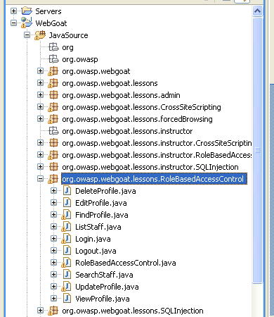
The action handler for RoleBasedAccessControl would be RoleBasedAccessControl.java. This is entry point into WebGoat for this Lab

  - For Example: RoleBasedAccesControl JSPs would be in the WebContent/Lessons/RoleBasedAccessControl folder inside the Eclipse Package Explorer
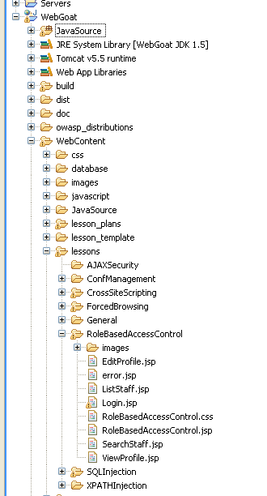

Except for the CrossSiteScripting lab the JSPs do not require modification

- All the labs are designed so the Method to be fixed has a _BACKUP method which contains the original source code.
  - For Example: RoleBasedAccessControl/ListStaff.java has one method where the developer is supposed to make their changes. ListStaff.getAllEmployees( WebSession s, int userID) it also has a corresponding ListStaff.getAllEmployees_BACKUP( …) method
  - The getAllEmployees method is the method you are supposed to fix in order to solve the lesson.
- RoleBasedAccessControl

WebGoat Access Control Policy

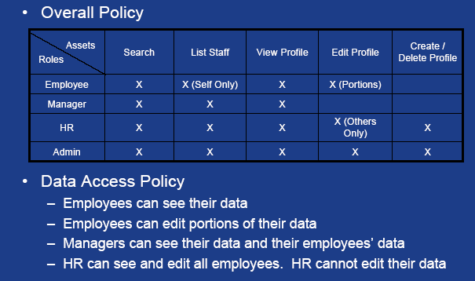

WebGoat Lab Database Schema

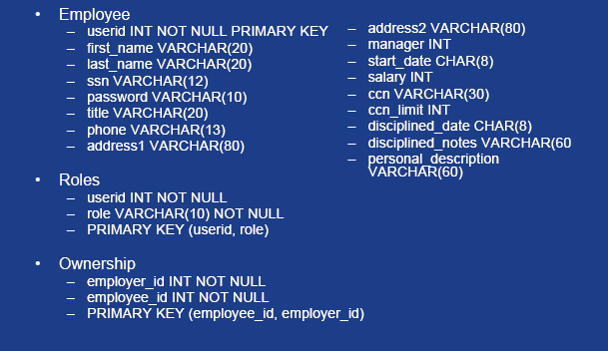

WebGoat Lab Organization Chart

